|  |  |
| --- | --- |
| **Data Structures & Algorithms**  Diploma in CSF, IT  Year 2/3 (2020/21) Semester 4/6 | **Week 9** |
| **2 Hours** |
| **Tutorial 9 – Trees** | |

1. Draw a **full** binary tree of height 3. correct

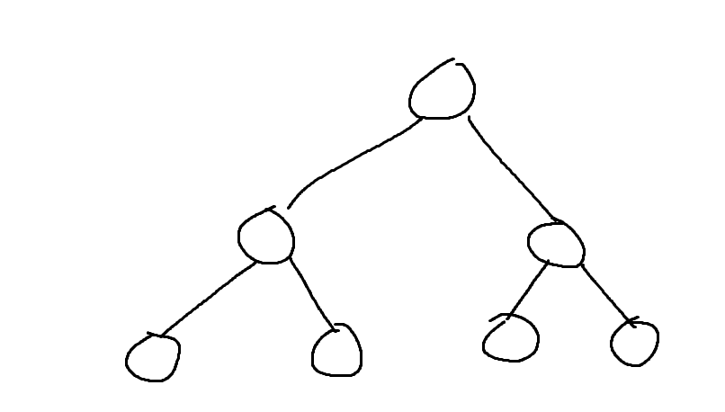

How many nodes are there in a **full** binary tree of height 3? 7 correct

What’s the formula? 2^3 –1 correct.

How many nodes are there in a **full** binary tree of height 10? 1023 correct.

Formula is 2^10 –1

1. Draw 3 **complete** binary trees of height 3.

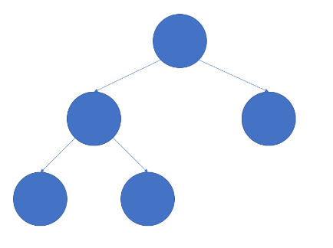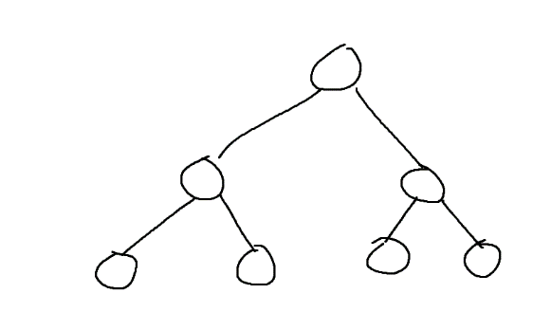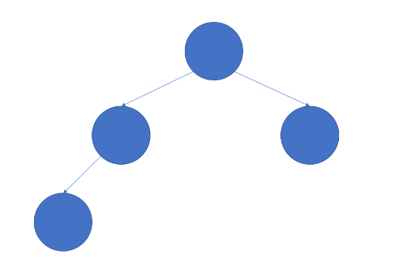 correct

5

4 6

1. Draw any 2 binary trees of height 3 that are neither **full** nor **complete**.

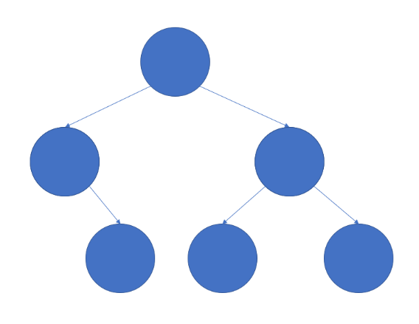 correct. Because the last level has one missing node on extreme left

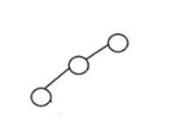 correct, one node missing on level 2.

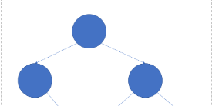



Correct. 2 nodes missing on extreme left in last level

4. A binary search tree is to be created with the items given below.

55 28 87 32 90 16 45 79 66 37

Assuming the items are inserted in the order given (i.e. from left to right),

1. Draw the binary search tree after the items are inserted

Show the tree as each item is added.

Insert 55: 55

Insert 28:

55

/

28

Insert 87:

55

/ \

28 87

Insert 32:

55

/ \

28 87

\

32

Insert 90:

55

/ \

28 87

\ \

32 90

Insert 16:

55

/ \

28 87

/ \ \

16 32 90

Insert 45:

55

/ \

28 87

/ \ \

16 32 90

\

45

Insert 79:

55

/ \

28 87

/ \ / \

16 32 79 90

\

45

Insert 66:

55

/ \

28 87

/ \ / \

16 32 79 90

\ /

45 66

Insert 37:

55

/ \

28 87

/\ / \

16 32 79 90

\ /

45 66

/

37

Correct.

1. Is the binary search tree balanced ?

No. Correct.

1. What is the output when the tree is traversed ***inorder*** ?

16 28 32 37 45 55 66 79 87 90 Correct.

1. What is the output when the tree is traversed ***preorder*** ?

55 28 16 32 45 37 87 79 66 90 Correct.

1. What is the output when the tree is traversed ***postorder*** ?

16 37 45 32 28 66 79 90 87 55 Correct.

1. What is the output when the tree is traversed ***level order*** ?

55 28 87 16 32 79 90 45 66 37 Correct.

5. A binary search tree is to be created with the items given below.

55 28 87 32 90 16 45 79 66 30

Assuming the items are inserted in the order given (i.e. from left to right),

1. Draw the binary search tree after the items are inserted

Insert 55:

55

Insert 28:

55

/

28

Insert 87:

55

/ \

28 87

Insert 32:

55

/ \

28 87

\

32

Insert 90:

55

/ \

28 87

\ \

32 90

Insert 16:

55

/ \

28 87

/ \ \

16 32 90

Insert 45:

55

/ \

28 87

/ \ \

16 32 90

\

45

Insert 79:

55

/ \

28 87

/ \ / \

16 32 79 90

\

45

Insert 66:

55

/ \

28 87

/ \ / \

16 32 79 90

/

66

Insert 30:

55

/ \

28 87

/ \ / \

16 32 79 90

/ \ /

30 45 66

1. Is the binary search tree balanced ? **No**

Correct.

1. What is the height of the binary search tree ? **5**

Correct.

1. What is the worst case comparisons required to search for an item ? O(height of tree) - 5 comparisons in this case Correct
2. What is the result when 88 is inserted into the tree ?

Insert 88:

55

/ \

28 87

/ \ / \

16 32 79 90

/ \ / /

30 45 66 88

1. What is the result when 16 is deleted from the tree ?

Delete 16:

55

/ \

28 87

\ / \

32 79 90

/ \ /

30 45 66

Correct.

1. What is the result when 79 is deleted from the tree ?

55

/ \

28 87

/ \ / \

16 32 66 90

/ \

30 45

Correct.

1. What is the result when 32 is deleted from the tree ?

55

/ \

28 87

/ \ / \

16 30 79 90

\ /

45 66

Correct.

6. A binary search tree is to be created with the items given below.

16 28 30 32 45 55 66 79 87 90

Assuming the items are inserted in the order given (i.e. from left to right),

1. Draw the binary search tree after the items are inserted

16

28

30

32

45

55

66

79

87

90

Correct.

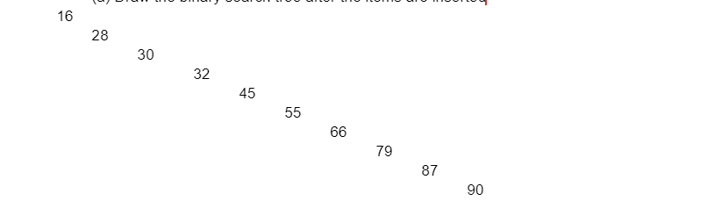

1. Is the binary search tree balanced ?

No. Correct

1. What is the height of the binary search tree ?

10. Correct

1. What is the worst case comparisons required to search for an item ?

10. Correct

This tree is called a degenerate tree – it looks like a linked list.